Install angular

* npm install –g @angular/cli
* Check version: ng version

Create new angular Application

ng new firstname

(firstname is the name of my application)

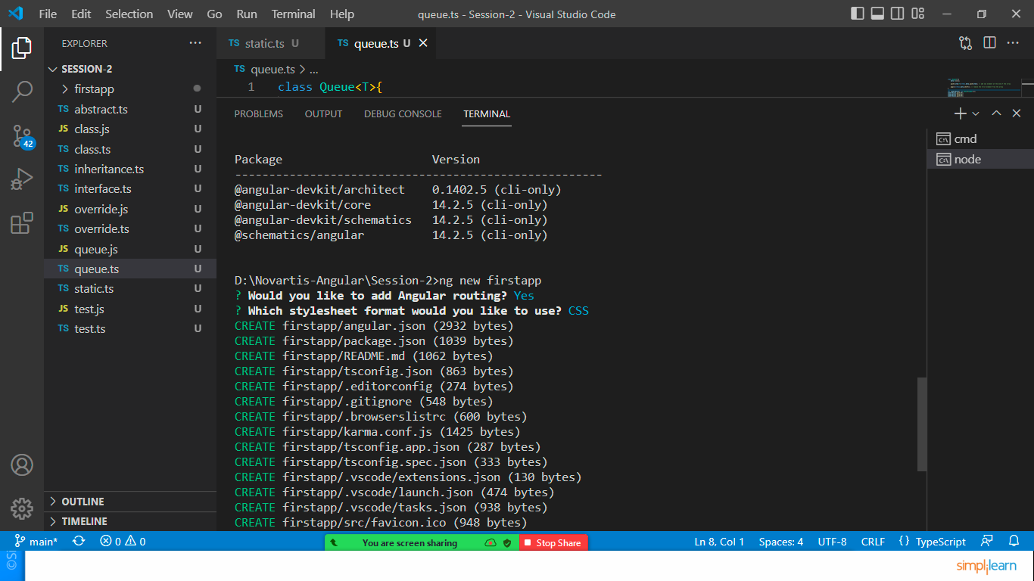

Add yes in routing and select CSS in stylesheet format.

Open the firstapp folder in VS code and execute ng serve command

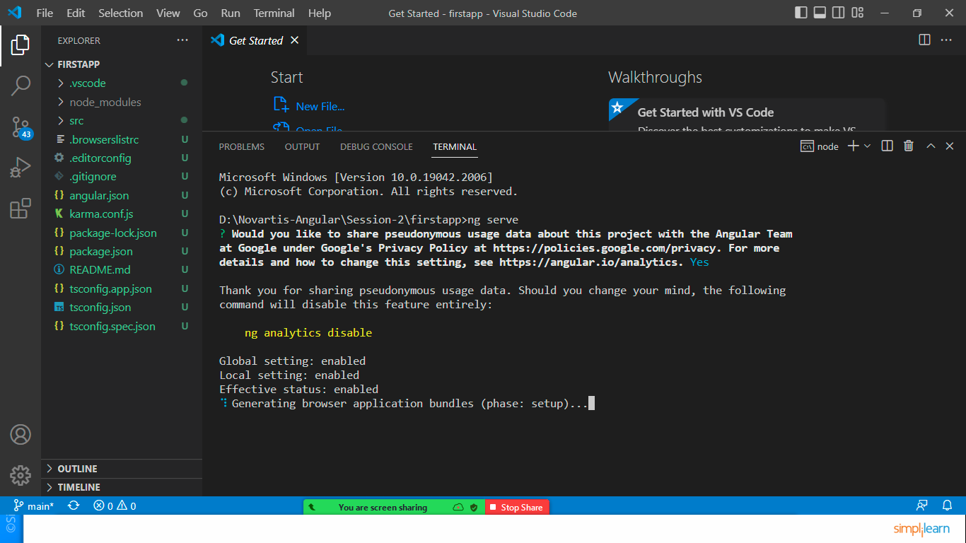

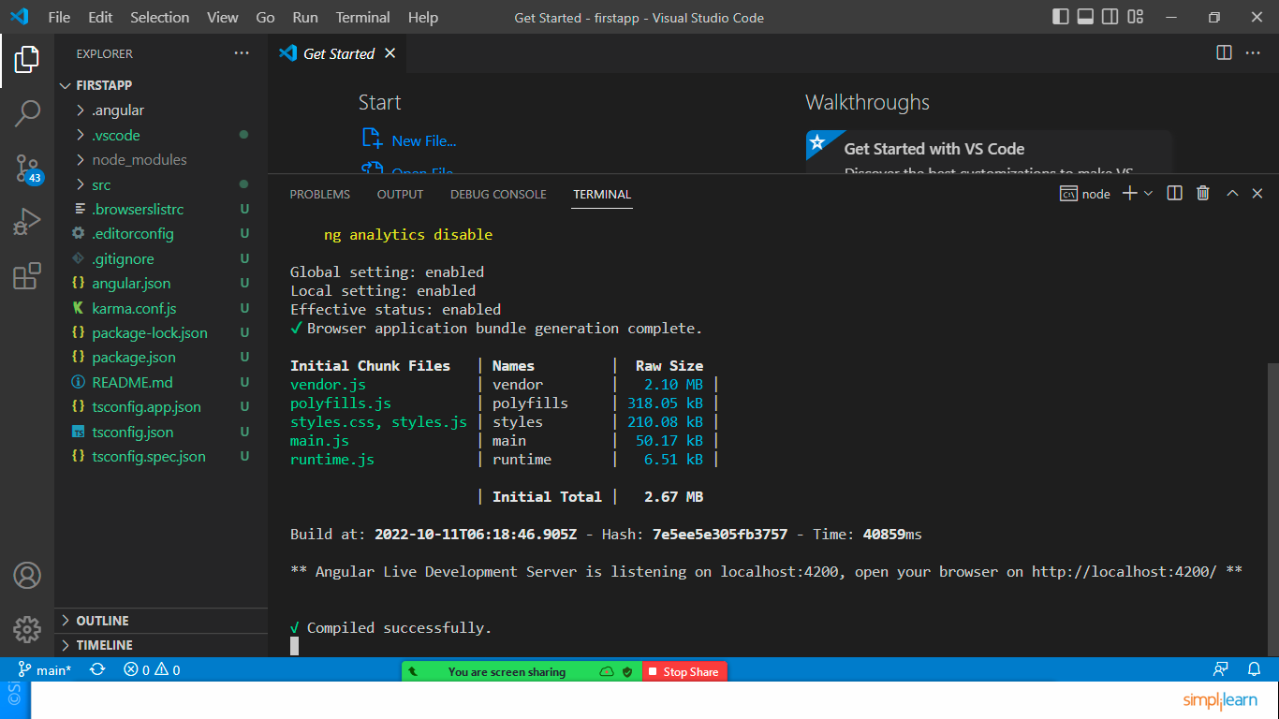

Open <http://localhost:4200> to see the output.

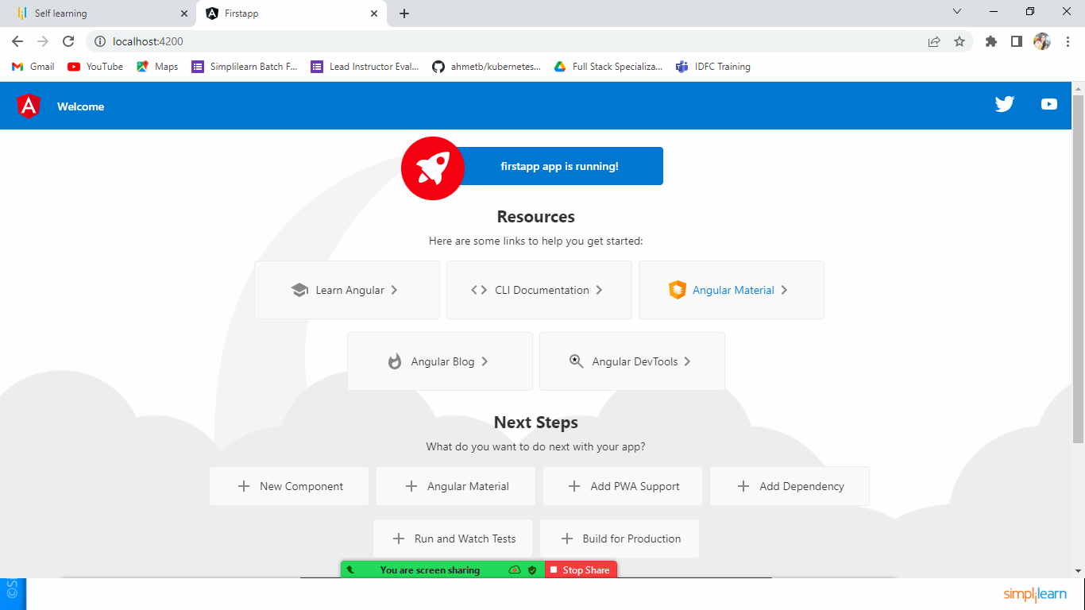

Default output of Angular Application.

Angular Application is divided into components

the root component is called app component

* App.component.ts -- logics
* App.component.css -- css files
* App.component.html -- html codes
* App.component.spec.ts -- Tetsting file

app.routing-module.ts -- used to implemenent the routing in App Module

app.module.ts -- module file for App Module (where you can mention all import,export, declaration, provider details)

Let’s edit app.component.html file

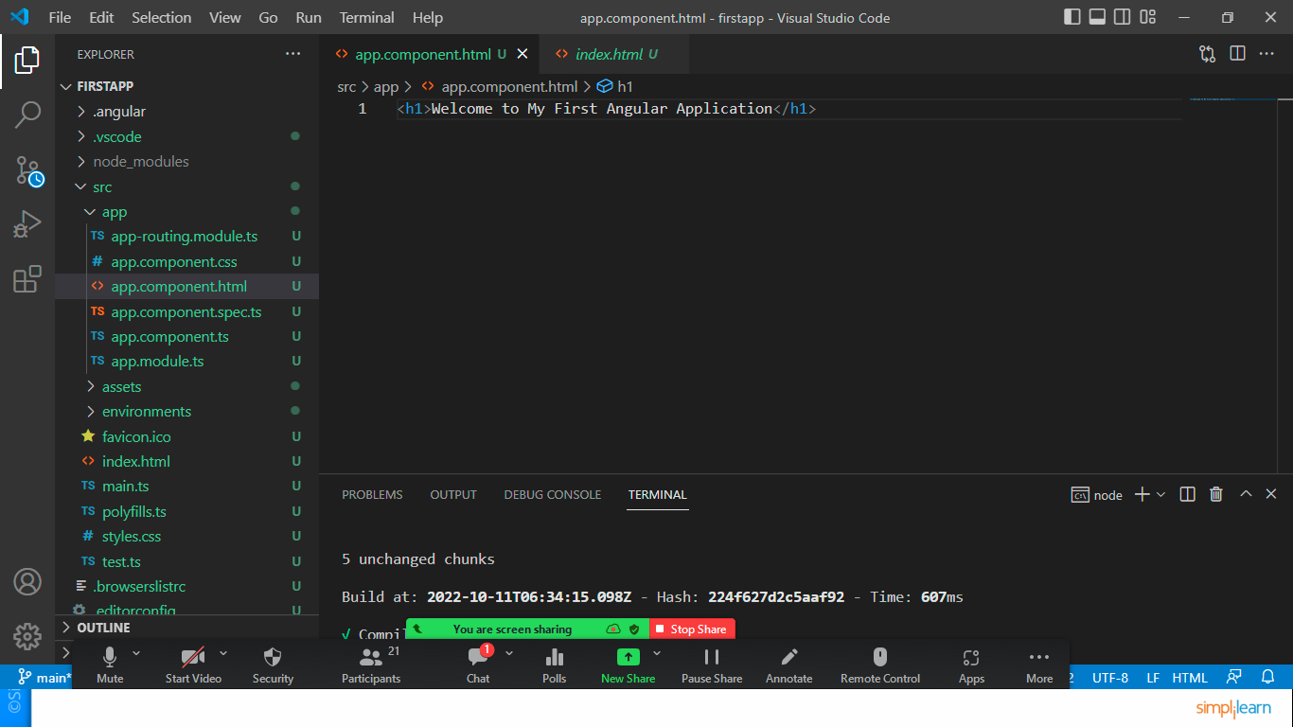

Save and check the output in browser.

Let’s create a new component by executing a command

* Ng generate component header
* Or sort cut : ng g c header

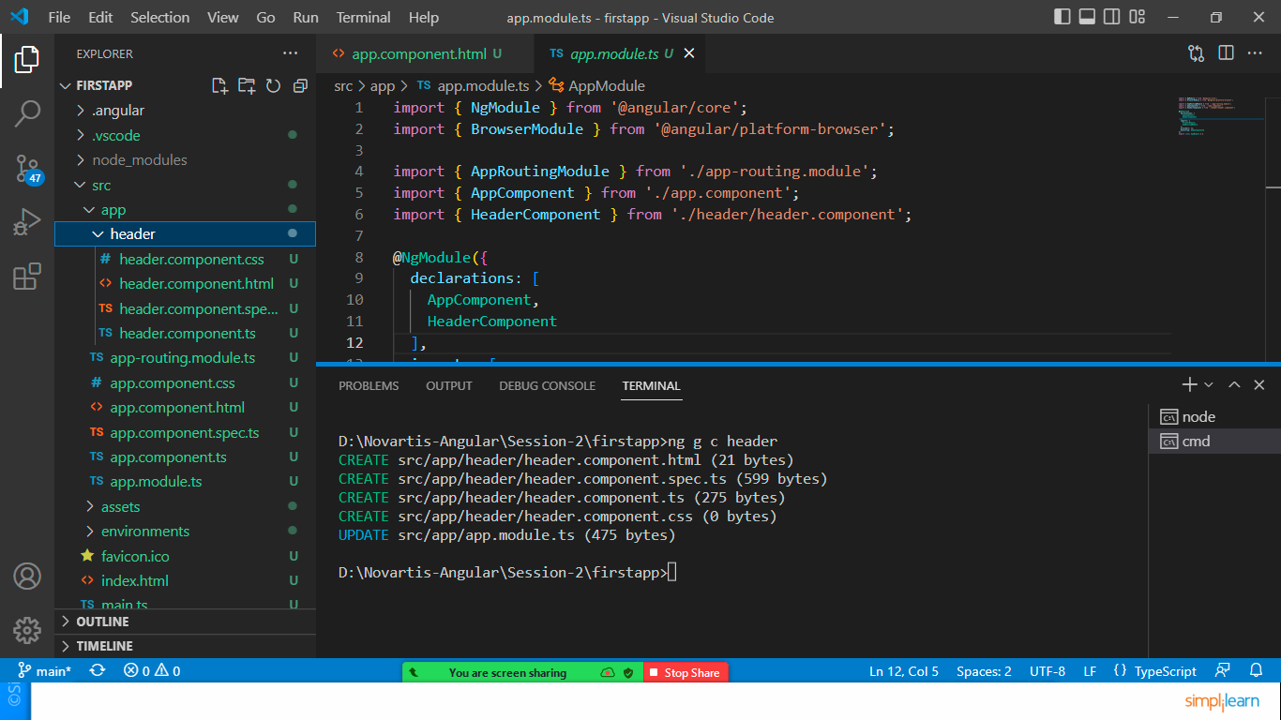

It will create 4 files in header folder and it will update the app.module.ts file as shown in image.

Open header.component.html

<h3>this is my Header Component</h3>

Open header.component.css

h3{

    background-color: burlywood;

}

Open header.component.ts and check the selector

@Component({

  selector: 'app-header',

  templateUrl: './header.component.html',

  styleUrls: ['./header.component.css']

})

export class HeaderComponent implements OnInit {

now copy this selector and add in app.component.html as a tag.

<h1>Welcome to My First Angular Application</h1>

<app-header></app-header>

Save and check page.

Set Up Bootstrap in Application

Install by using command

* npm install bootstrap

Edit styles.css

@import '../node_modules/bootstrap/dist/css/bootstrap.min.css';

To use bootstrap edit the code of header.component.html and check the output

<button class="btn btn-primary">Header Component</button>

<button class="btn btn-secondary">Header Component</button>

<button class="btn btn-warning">Header Component</button>

<button class="btn btn-success">Header Component</button>

<button class="btn btn-info">Header Component</button>

<button class="btn btn-danger">Header Component</button>

Now create new component for data binding

Ng g c home

Open [home.component.ts](http://home.component.ts)

Declare 2 variables

export class HomeComponent implements OnInit {

  name:string="Sonam Soni";

  url:string="http://www.google.com"

  constructor() { }

  ngOnInit(): void {

  }

}

Let’s bind the values in template [home.component.html](http://home.component.html)

<h3 class="bg-warning text-center"> Home Component</h3>

<!--Interpolation-->

<p>Welcome {{name}}</p>

<!--Property Binding using attribute-->

<a [href]="url">Click to open Google</a>

Attach this home component in app.component.html

<h1>Welcome to My First Angular Application</h1>

<app-header></app-header>

<app-home></app-home>

Save the same and check the output.